14th August 2020- by Lady Kendal Jaggar

THE FALLEN HERO’S GRAVE
RESTORATION WORK ACROSS THE GLOBE
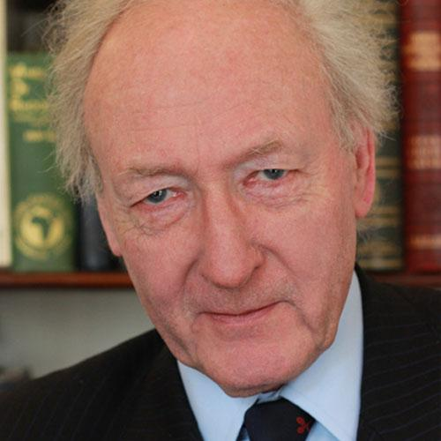Algy Cluff OBE, DL
CHAIRMAN AND FOUNDER
THE REMEMBRANCE TRUST
HONOURING THE PAST T0 IMPROVE OUR FUTURE

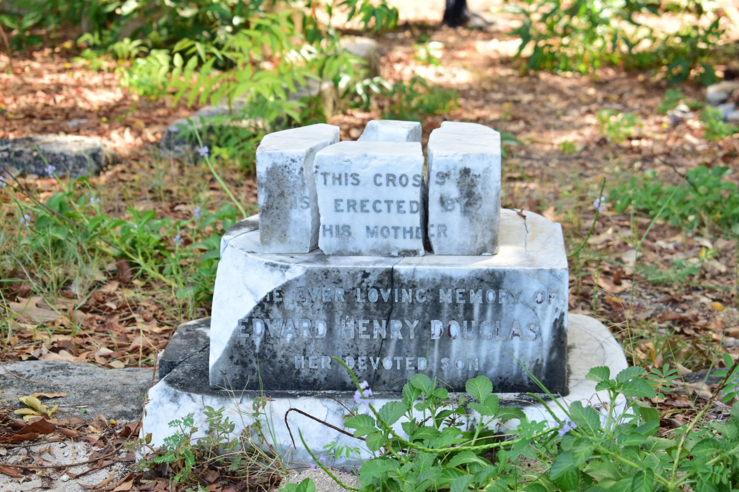

THE FALLEN SOLDIER
Remembrance is about the common soldier - and that is why it matters so much as stated by Charles Moore.
Across the globe so many fallen soldiers lay in broken and hidden graves with their inscriptions almost invisible to the human eye. We as a global population all understand that heritage is an overwhelming and an important component of a nation’s identity, one in which we all focus on WW1 and WW2 with respect across the globe shown on important memorable dates. Why it is also important to remember the fallen hero before 1914 and the many conflicts of war that have taken place.
The Carribean a popular destination for the foreign traveller, is undergoing restorations as is Zanzibar to honour the soldiers that lay as a remembrance of a war. The walking tourist who passes by with the words “Time to move on” echoes within their mind yes life does move on but does it have to be a doctrine of forgetting.

AFRICA - Grave island, Zanzibar-Chapwani Island
A neglected Navel Cemetery of sailors who died largely around the 1870’s when the British arrived in Zanzibar to extend their trading empire, also to establish Royal Navy Bases in Zanzibar. The plight also was to tackle the slave trade, which was still flourishing on the neighbouring islands of Pemba and Funzi.
Researchers are currently exploring the extent of the restoration required, also using photographs taken on the expedition site. These graves are extremely worn, broken, and faded inscriptions hidden by overgrown vegetation.
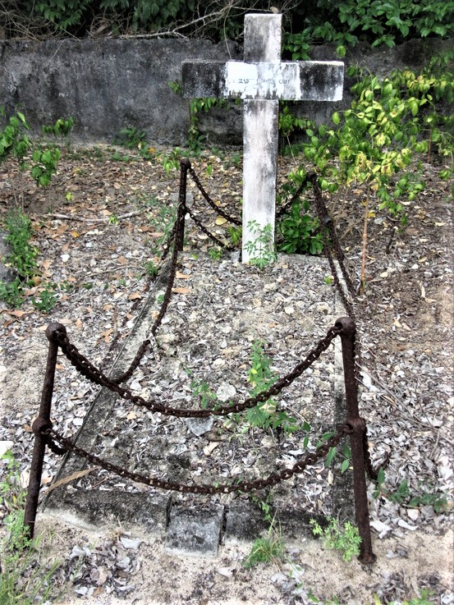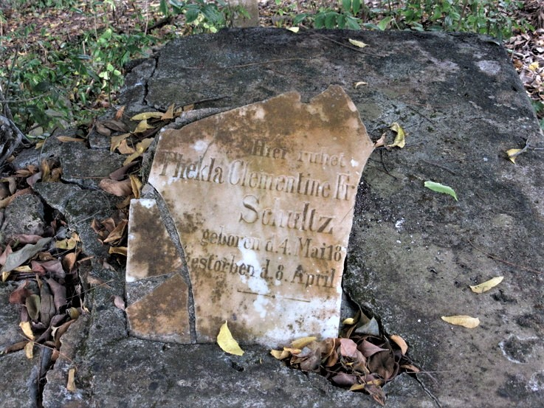
CARIBBEAN - St Paul’s Falmouth, Antigua
Discussions are currently in place for the restoration of the Naval and Military graves from the 18th and 19th century in the Shirley Heights cemetery. Mrs Joanne Lambert, a Trust volunteer is currently organizing a 100k fundraiser, to restore at least three, hopefully eight other different cemeteries currently identified as in a state of neglect on the island . The Trust in conjunction with The National Parks of Antigua, The World Heritage Fund and other agencies lead the restoration works, aiming for completion by 2020.
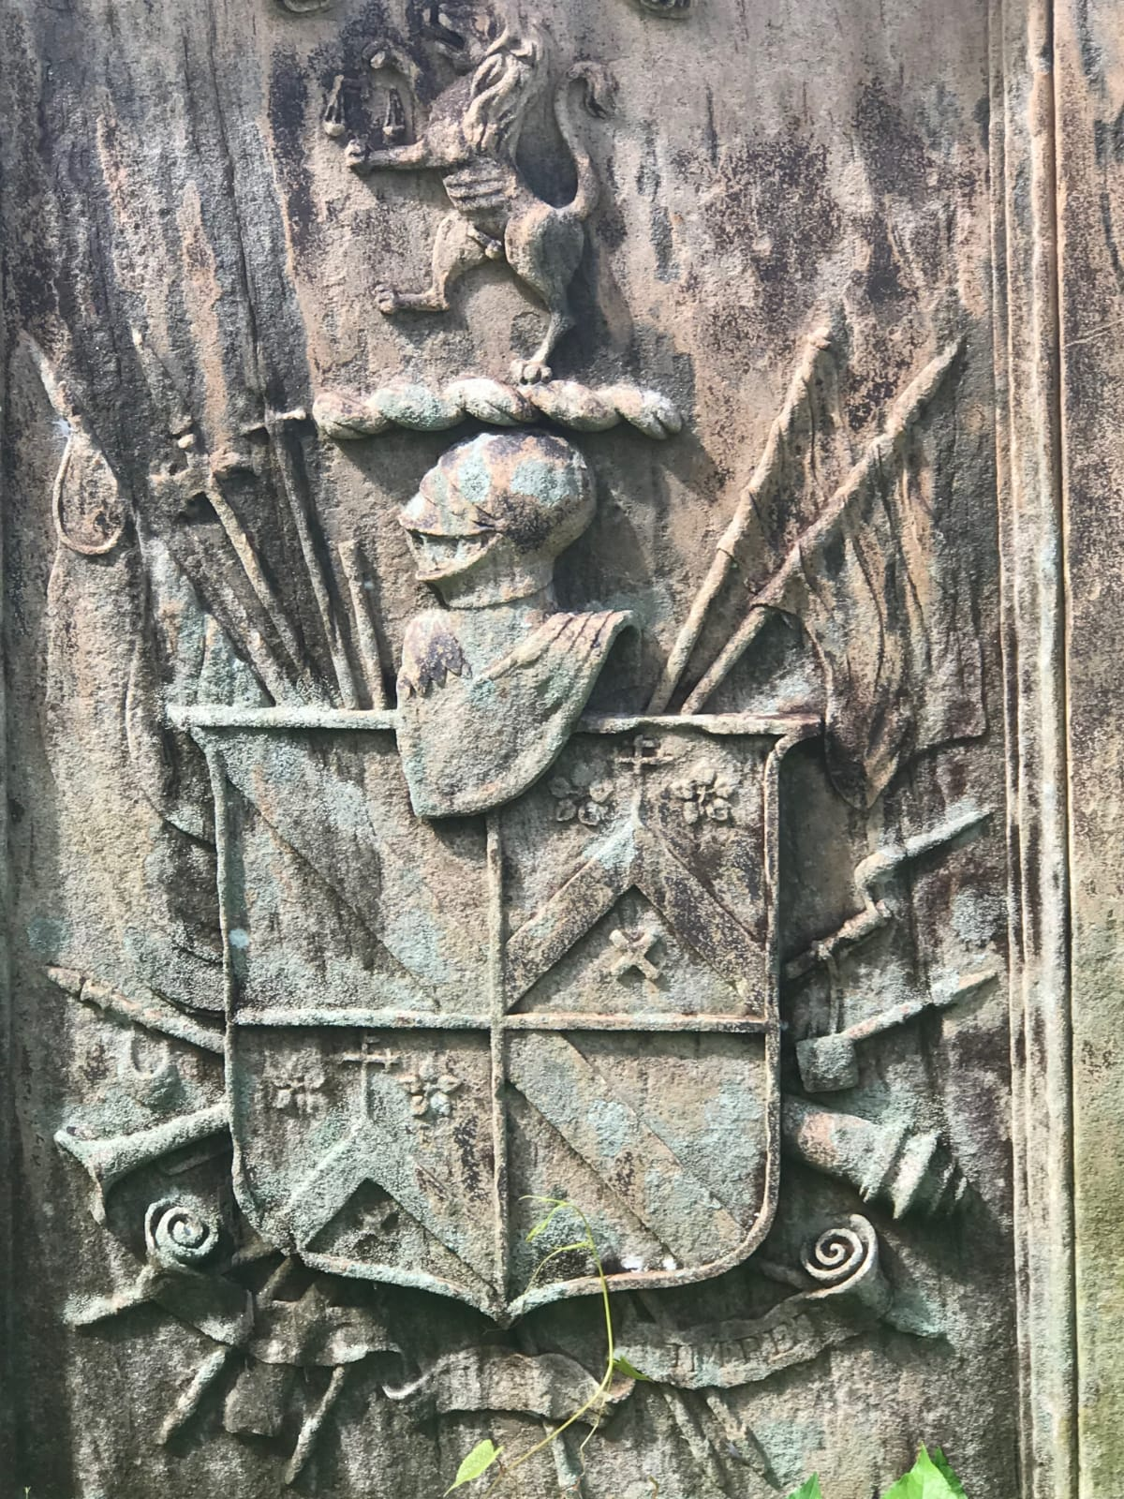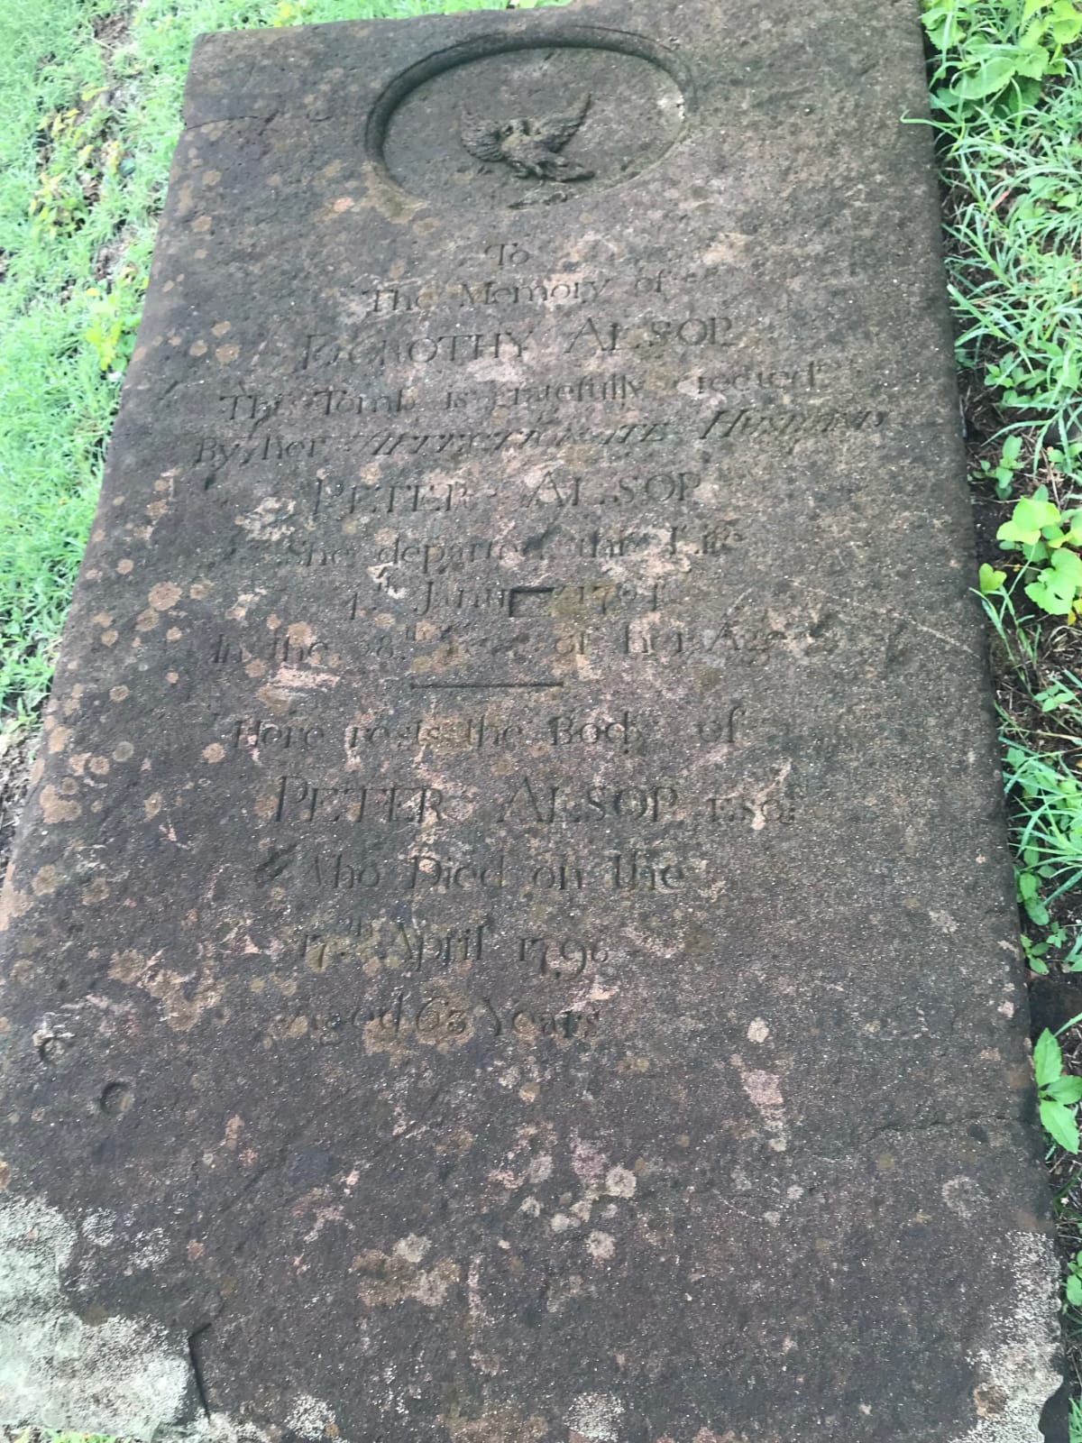
*DUE TO COVID19 WORKS HAVE CURRENTLY BEEN ON HOLD IN ZANZIBAR
COLDSTREAM CEMETERY, BAYONNE - FRANCE
The battle of Bayonne in 1914, was a significant event in the Peninsula Wars for the Coldstream Guards. The oldest regiment In the British Army and is still in continuous active service. General George Monck founded this division in Coldstream, Scotland in 1650 as part of the New Model Army. These graves have had new concrete laid replacing their cracked and broken stone work. The pictures below were taken by two Coldstream Veterans Robert Kay-Shuttleworth and Ian Cunningham whilst on a Cycling holiday in France.
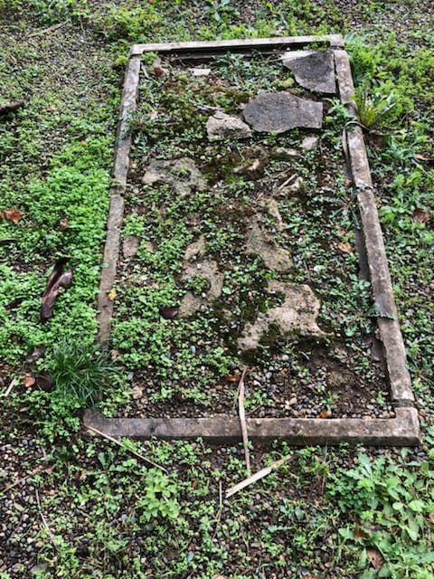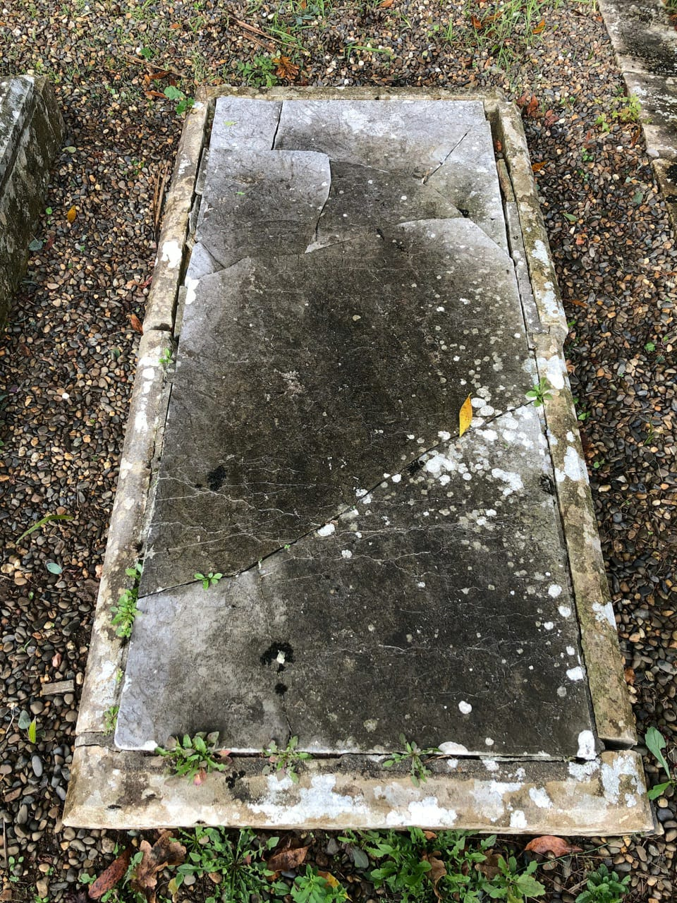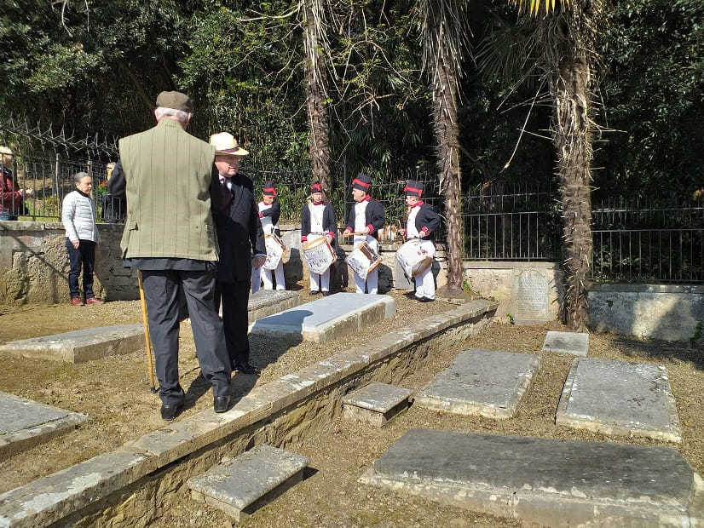
BEFORE AFTER
ST SAVIOUR'S CHURCH - JERSEY
Over 100 fallen hero’s lay in this ancient place of worship as the Church of St Saviour’s sits amongst the trees amid a fascinating cemetery. The Rector of St Saviour’s Church contacted The Trust regarding the 100 burials that had taken place representing army veterans who fought in the period of 1793-1815 of which 62 fought in the Peninsula War or Waterloo. The Trust awarded funds of £4345.00 for a memorial plaque recording these soldiers' names including the Boer War and the Crimean War.
CRIMEAN WAR, 1853-1856
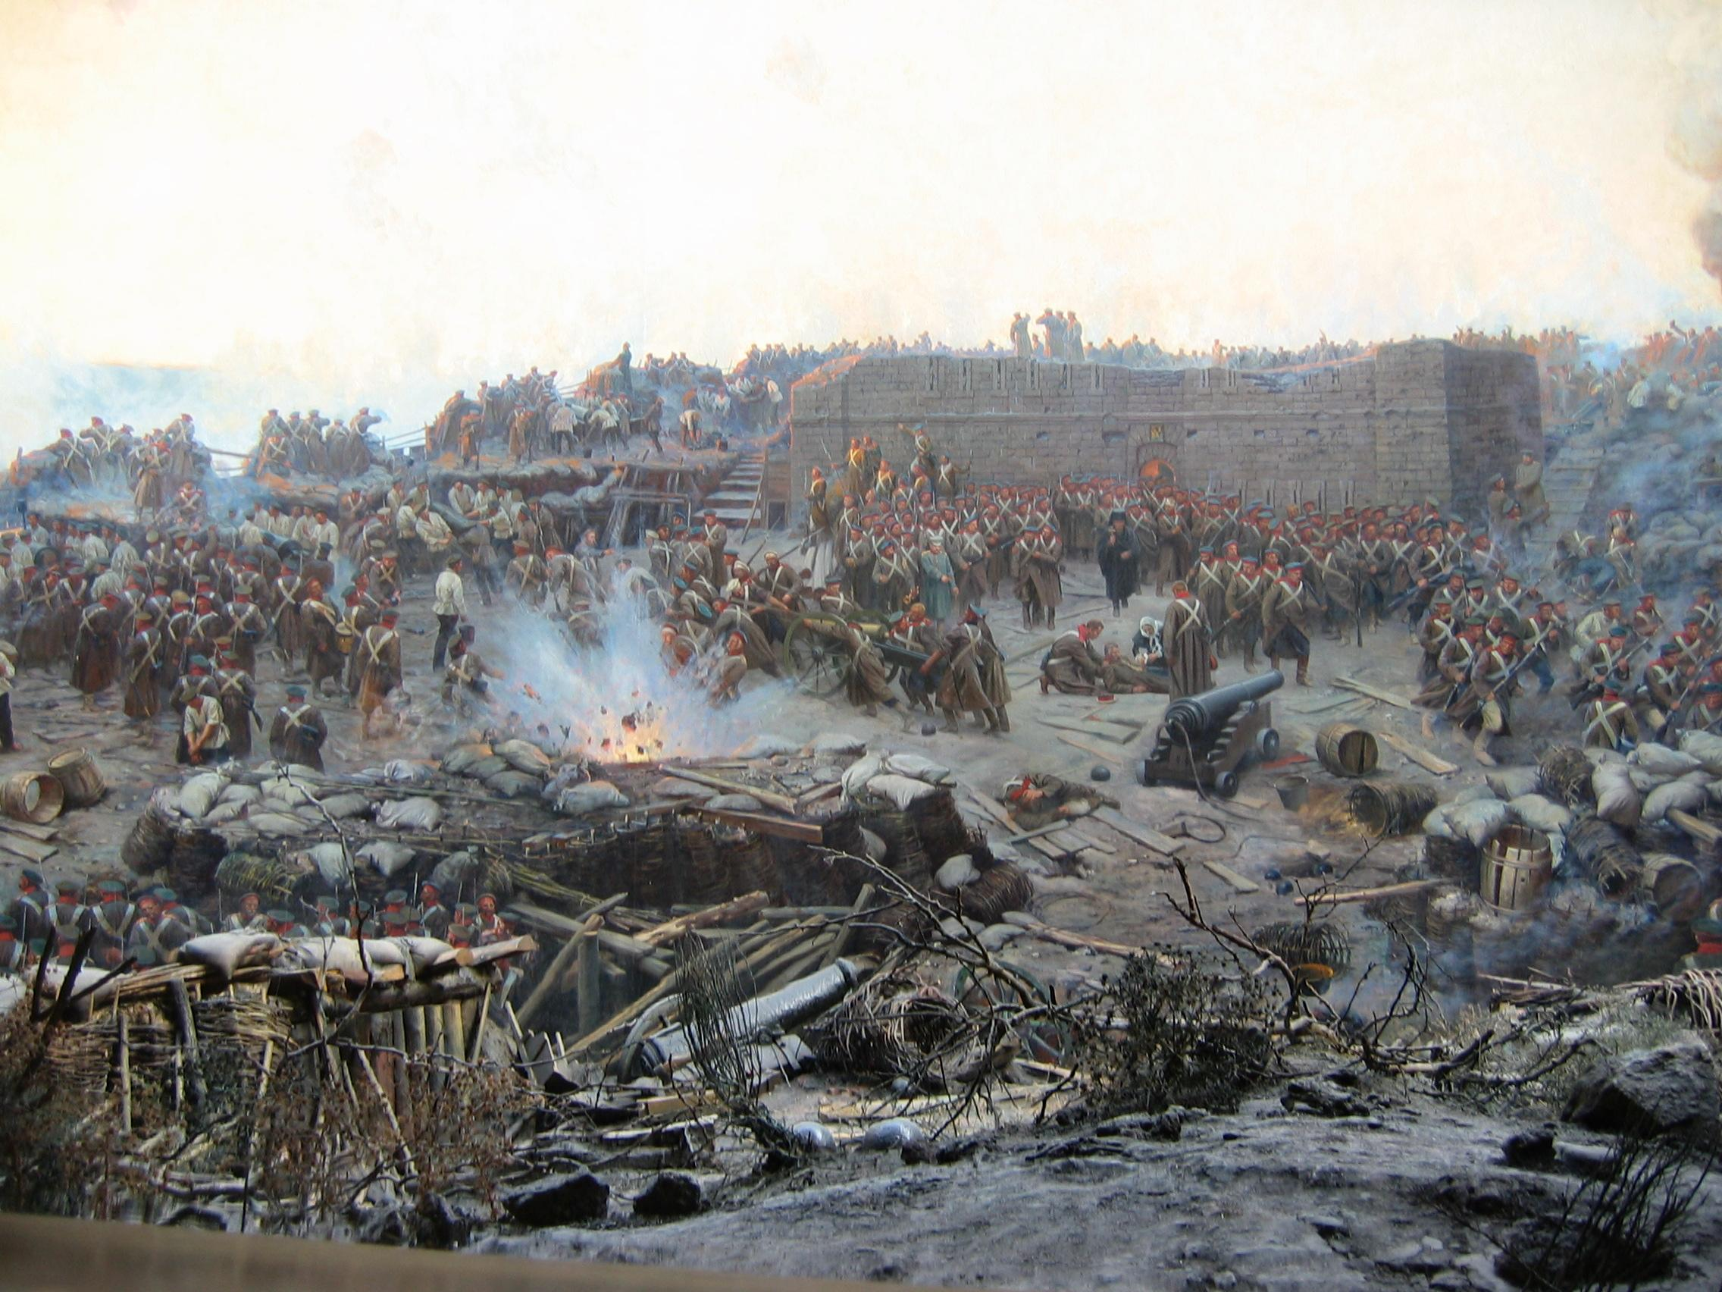
October 1853 to March 1856 a military conflict between Russia and an alliance made up of The United Kingdom, Sardinia, France and the Ottoman Empire to which Russia was defeated on the 30th March 1856. Most of these soldiers' graves are beyond repair, therefore, The Trust have proposed a new memorial using the materials from the old graves of the Russian and British Soldiers killed there. Discussions at the Russian Embassy requested that the trust forward their proposal for a memorial to be erected in Crimea.
THE GUARDS PARACHUTE ASSOCIATION
The Trustees made a one-off single payment to The Guards Parachute Association, a £3000.00 donation. Towards their project to erect a memorial of all Airborne Guardsmen. This memorial will be engraved with all the regimental cap badges, the Household Division Star and the Airborne Forces Pegasus also a plinth with a full explanation. Algy Cluff OBE the Chairman of The Remembrance Trust explains as we talk over this wonderful Charity, that the memorial will be erected at The National Memorial Arboretum in Staffordshire.
COLCHESTER - ESSEX, ENGLAND
The Grade 1 listed grave of Jesse Jones who served in the First World War, has been awarded by the trustees the sum of £3500.00 to restore the grave which lays in the St Botolph’s Priory, Colchester. Jesse Jones served in the First Foot Guards during the Napoleonic War and fought in several battles, but particularly at the Battle of Barossa and at Waterloo. When Jesse retired from the regiment he was appointed as Adjutant to the EastEssex Militia
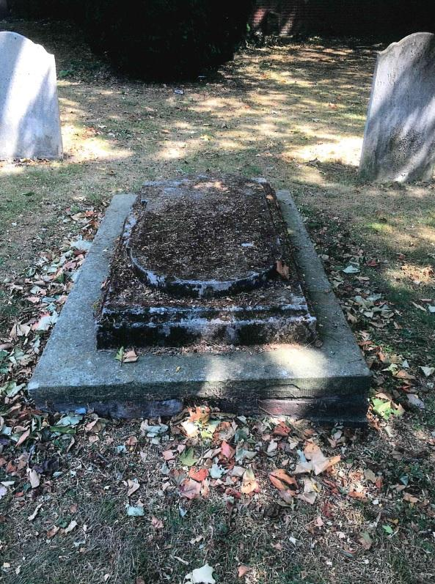

ISLE OF WIGHT & DOVER, KENT, ENGLAND
A restoration programme of mostly Royal Navy personel’s graves will start this year. This restoration is currently in the research and discussion stage, and one which will honour to see the fallen hero’s graves when restored. Algy Cluff OBE Chairman and founder of the War Memorial Trust 2003-2014 is currently in talks regarding the 60th Rifles monument outside The Remembrance Trust’s offices located at Waterloo Crescent, Dover, Kent.
ICKHAM CHURCHYARD, KENT
Captain Frederick Swann, served as a Captain for the Grenadier Guards, also serving in the final actions of the Peninsular Campaign and also at Waterloo. His grave lays in the cemetery of St. John the Evangelist Church in Ickham. The Remembrance Trust is intending to restore his grave. Captain Frederick Swann enrolled in the First Foot Guards in October 1813, he died aged 74.

